**Power BI Assignment 5**

1. Explain DAX.

Data Analysis Expressions (DAX) is a library of functions and operators that can be combined to build formulas and expressions in Power BI, Analysis Services, and Power Pivot in Excel data models. DAX is essentially a programming language that is used for creating calculated columns, measures, and custom tables. DAX can be used to solve a number of calculations and data analysis problems, which can help to create new information from data that is already in your model.

1. Explain datasets, reports, and dashboards and how they relate to each other?

A dataset is a collection of data that you import or connect to. Power BI lets you connect to and import all sorts of datasets and bring all of it together in one place. Datasets can also source data from dataflows. Datasets are associated with workspaces and a single dataset can be part of many workspaces. A Power BI report is one or more pages of visualizations such as line charts, maps, and treemaps. All of the visualizations in a report come from a single dataset. Power BI Desktop can combine more than one data source into a single dataset in a report, and that report can be imported into Power BI. A dashboard is something you create in the Power BI service or something a colleague creates in the Power BI service and shares with you. It is a single canvas that contains zero or more tiles and widgets. Each tile pinned from a report or from Q&A displays a single visualization that was created from a dataset and pinned to the dashboard. Entire report pages can also be pinned to a dashboard as a single tile.

1. How reports can be created in power BI, explain two ways with Navigation of each.

First step is to get the data and load it. Once data is loaded, the report can be designed in the Power BI Desktop. Then the report should be saved in the report server. Then it can be accessed from the web portal. There's a new way to create reports quickly in the Power BI service. Instead of downloading the Power BI Desktop app and importing the data, you can paste data straight into Power BI on the web, and Power BI automatically generates visuals for you. In the navigation pane in the Power BI service, you can select the Create button that opens a page where you can select your data source. Currently, only creating a report based on an existing dataset, or typing or pasting data directly in a table is supported. Then click on auto create report. Power BI creates a new dataset for you, and autogenerates a summarized view of your data. These autogenerated visuals propel you from raw data to insights faster than ever.

1. How to connect to data in Power BI? How to use the content pack to connect to google analytics? Mention the steps.

With Power BI Desktop, you can connect to many different types of data. These sources include basic data sources, such as a Microsoft Excel file. You can connect to online services that contain all sorts of data, such as Salesforce, Microsoft Dynamics, Azure Blob Storage, and many more. To connect to data, from the Home ribbon select Get data. The Get Data window appears. You can choose from the many different data sources to which Power BI Desktop can connect. Power BI services offers a suite of Content Packs. Basically a content pack is a connection between Power BI services and a data set. These content packs include pre-built dashboards and reports that will ignite your data. To connect to content pack, in the Power BI service, go to Get Data. In the content pack library option choose services. The available content packs will be shown from that choose google analytics. Then choose the authentication type and property. Once you click import the content pack will be imported.

1. How to import Local files in Power BI? Mention the Steps.

In Power BI, you can connect to or import data and reports from three types of files. Click on Get Data option and in the categories section click on File. This will show different options as shown in screenshot. Choose the type of file and click connect. Once successfully connected the data will be shown, from this point you can load or transform data and use it in Power BI.

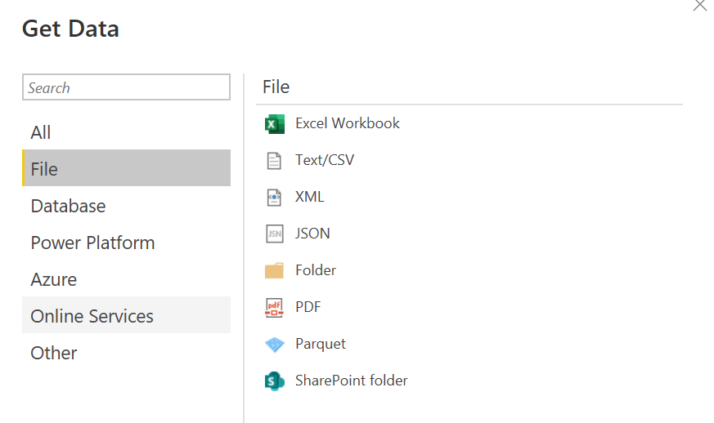

1. In Power BI visualization, what are Reading View and Editing view?

There are two modes for interacting with reports in the Power BI service: Editing view and Reading view. If you are a business user, then you are more likely to use Reading view to consume reports created by others. Editing view is used by report designers, who create the reports and share them with you. Reading view is your way to explore and interact with reports created by colleagues. Even in Reading view, the content isn't static. You can dig in, looking for trends, insights, and other business intelligence. Slice and dice the content, and even ask it questions using your own words.